**Funnel Analysis Report**

**Swiggy’s Business Case**

(Year 2019)

* Yogesh Patil

Date of Report: **3 November 2023**

**Table of Contents**

1. Executive Summary

2. Analysis

3. Conclusion

4. Recommendations

1. **Executive Summary**

This analysis provides insights into Swiggy's performance in 2019, with a focus on understanding changes in order volume, traffic, and overall conversion rates. The analysis is based on the 'Funnel Case Study Data'.

1. **Analysis**
   * **January – 2019**

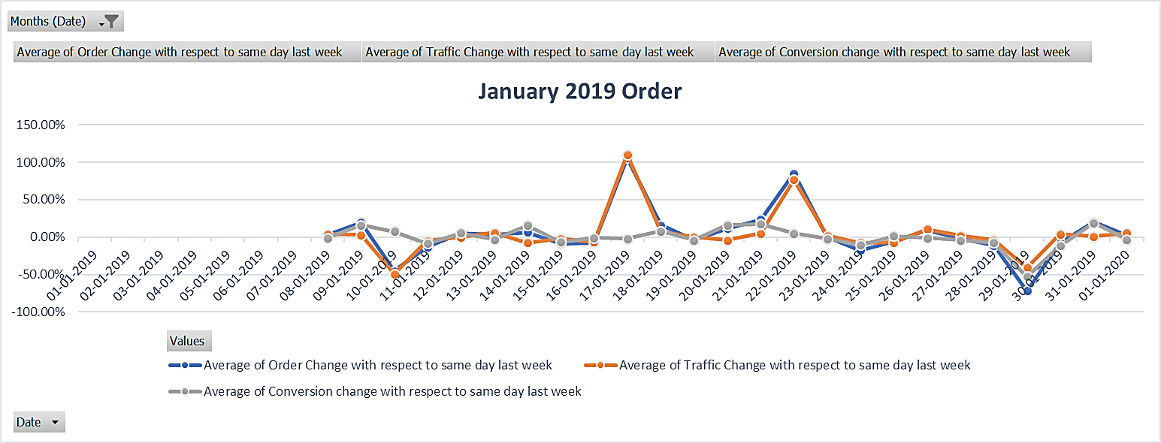

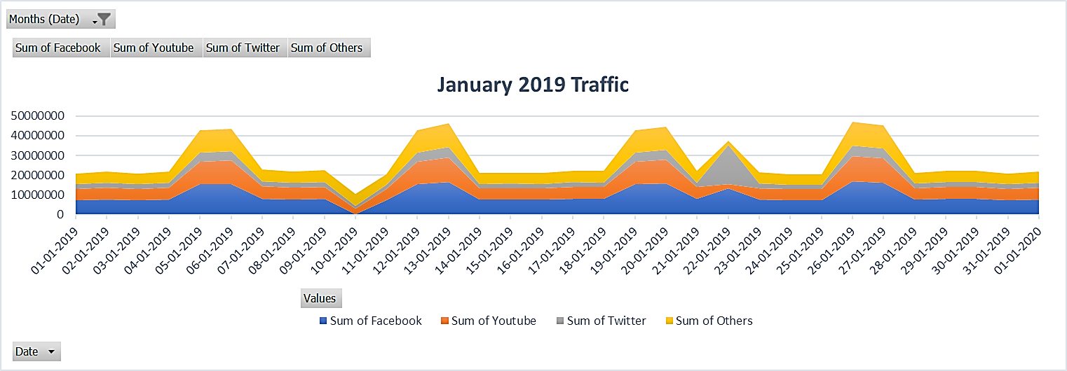

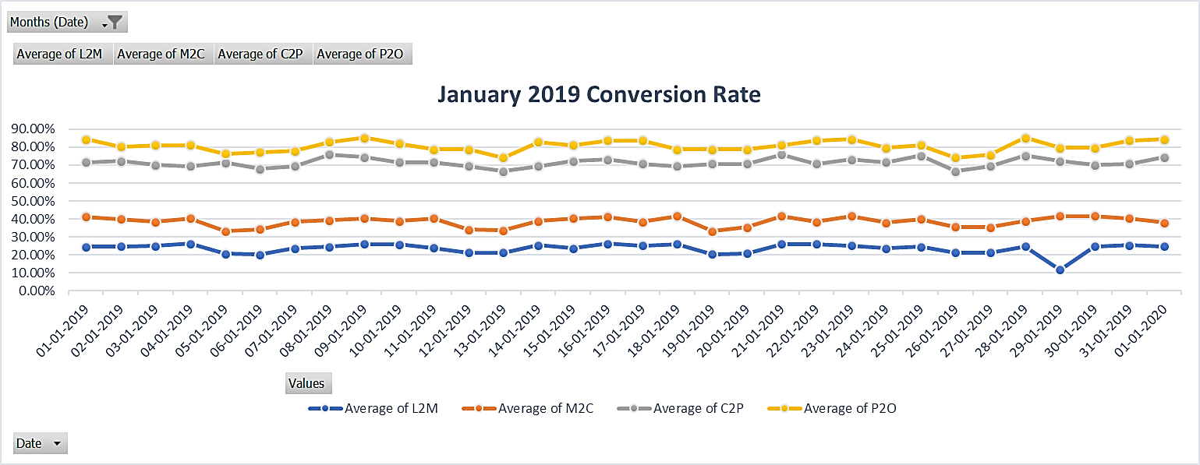

|  |  |  |
| --- | --- | --- |
| Date | Order Fluctuation | Reason |
| 10-01-19 | 45% Drop | A 49% **Drop in Traffic** compared to the same day last week (03-01-2019). |
| 17-01-19 | 106% Rise | A 110% **Rise in Traffic** compared to the same day last week (10-01-2019). |
| 22-01-19 | 85% Rise | A 77% **Rise in Traffic** compared to the same day last week (15-01-2019). |
| 29-01-19 | 72% Drop | - A 40% **Drop in Traffic** compared to the same day last week (22-01-2019).  - **Drop in L2M** Conversion Rate (from 26% to 12%) due to a **low Count of Restaurants** (2,74,777, the lowest in the year). |

* + **February – 2019**

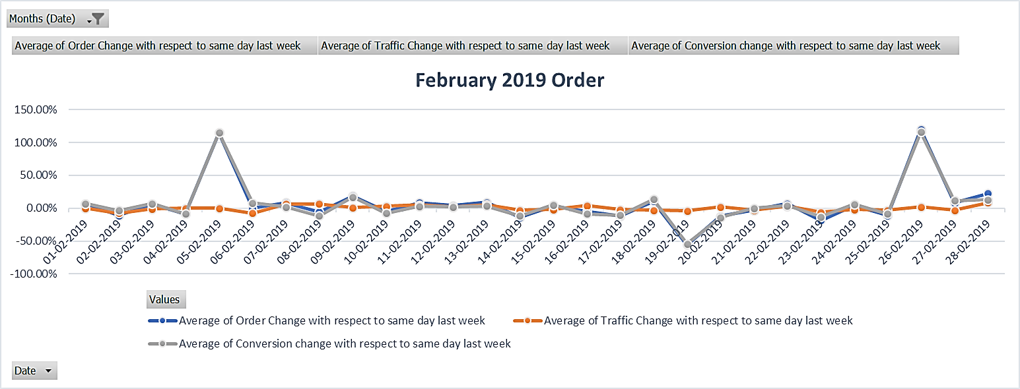

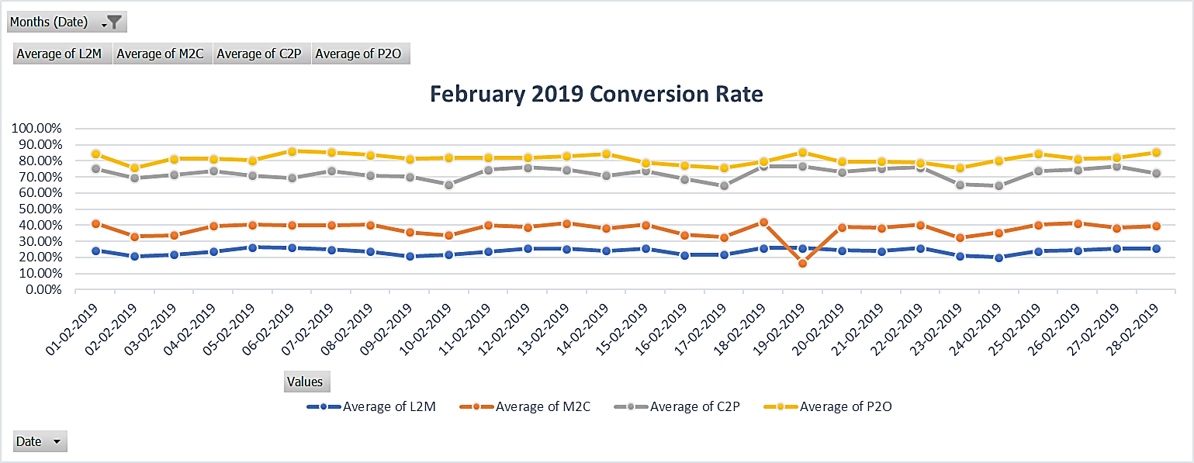

|  |  |  |
| --- | --- | --- |
| Date | Order Fluctuation | Reason |
| 05-02-19 | 115% Rise | An **increase in L2M** (Listing to Menu) conversion rate from 12% to 26% compared to the same day last week (29-01-2019). |
| 19-02-19 | 56% Drop | A **decrease in M2C** (Menu to Cart) conversion rate from 39% to 17% compared to the same day last week (12-02-2019). |
| 26-02-19 | 120% Rise | A **rise in M2C** (Menu to Cart) conversion rate from 17% to 41% compared to the same day last week (19-02-2019). |

* + **March – 2019**

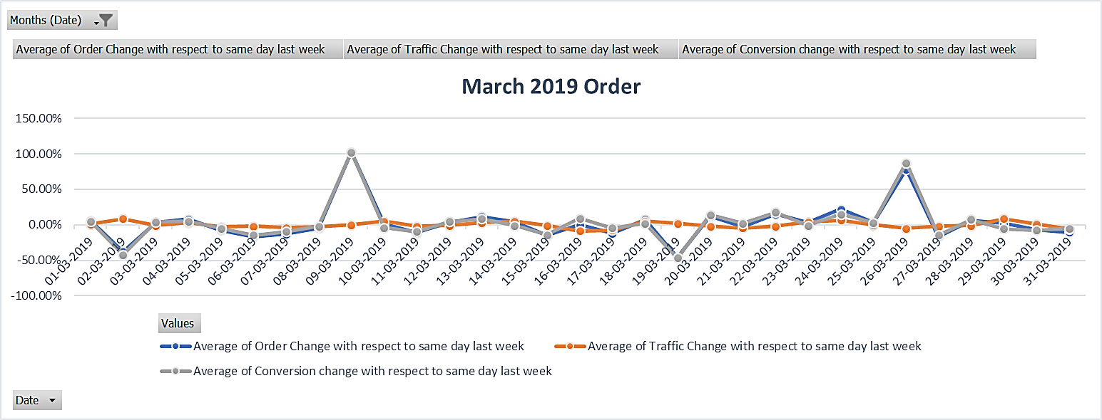

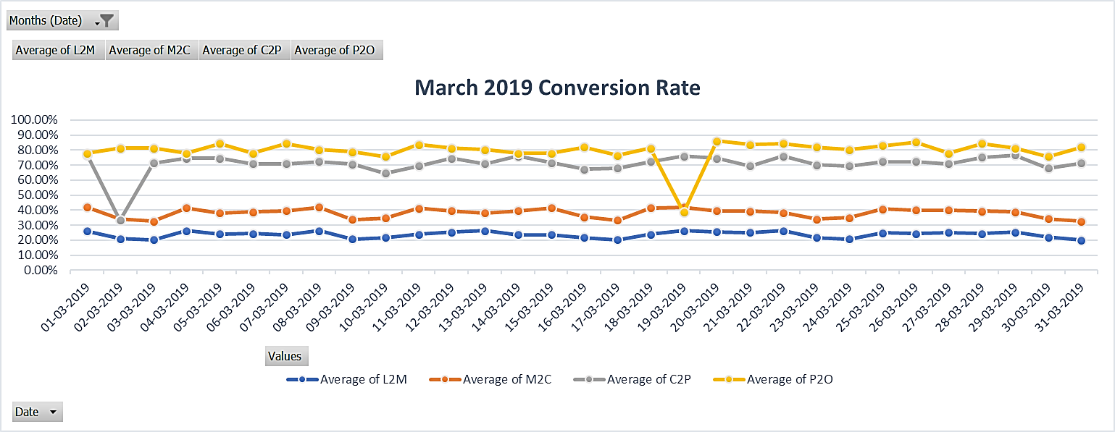

|  |  |  |
| --- | --- | --- |
| Date | Order Fluctuation | Reason |
| 02-03-19 | 38% Drop | A **drop in C2P** (Cart to Payment) conversion rate (from 65% on 23-02-19 to 33% on 02-03-19, compared to the same day the previous week) due to the **rise in Average Delivery Charges per Order** to Rs. 56. |
| 09-03-19 | 102% Rise | A **rise in C2P** (Cart to Payment) conversion rate (from 33% on 02-03-19 to 71% on 09-03-19, compared to the same day the previous week). |
| 19-03-19 | 46% Drop | A **drop in P2O** (Payment to Order) conversion rate (from 81% on 12-03-19 to 39% on 19-03-19, compared to the same day the previous week) due to the **drop-in Success rate of Payments to 65%**. |
| 26-03-19 | 78% Rise | A **rise in P2O** (Payment to Order) conversion rate (from 39% on 19-03-19 to 85% on 26-03-19, compared to the same day the previous week). |

* + **April – 2019**

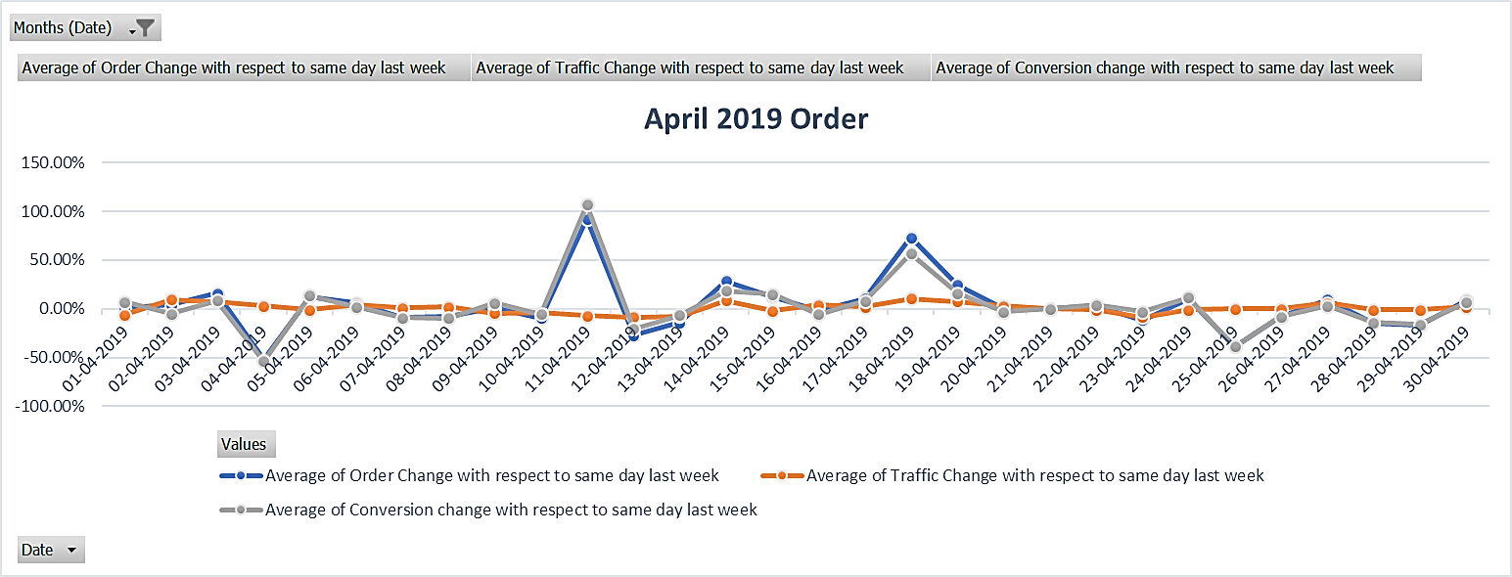

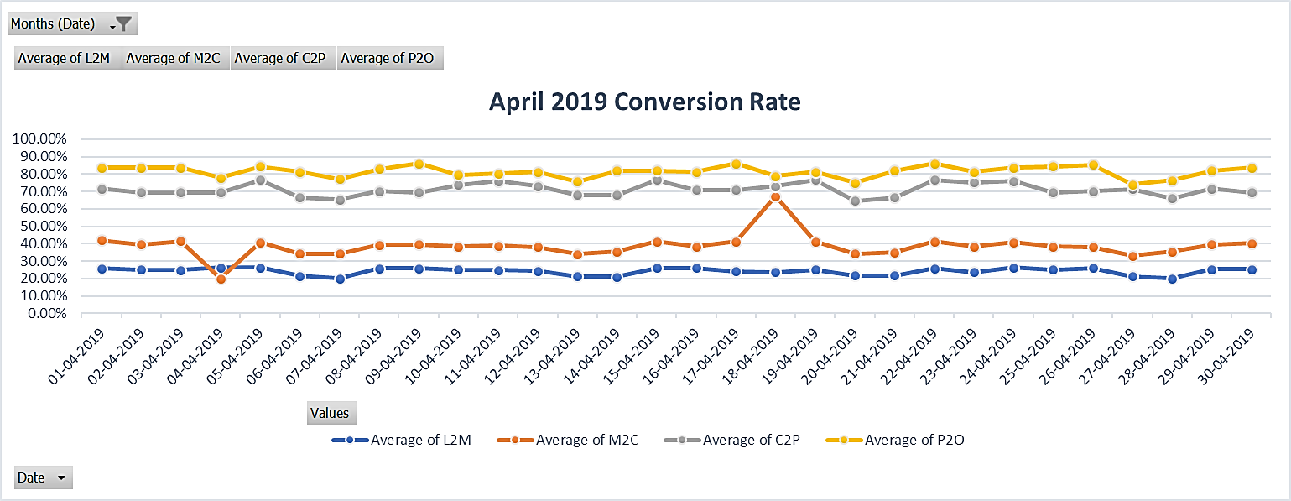

|  |  |  |
| --- | --- | --- |
| Date | Order Fluctuation | Reason |
| 04-04-19 | 52% Drop | A **drop in M2C** (Menu to Cart) conversion rate (from 39% on 28-03-19 to 20% on 04-04-19, compared to the same day the previous week) due to the **drop in Average Discount Percent per Order to 10%.** |
| 11-04-19 | 92% Rise | A **rise in M2C** (Menu to Cart) conversion rate (from 20% on 04-04-19 to 39% on 11-04-19, compared to the same day the previous week). |
| 18-04-19 | 73% Rise | A **rise in M2C** (Menu to Cart) conversion rate (from 39% on 11-04-19 to 67% on 18-04-19, compared to the same day the previous week) due to **the rise in Average Discount Percent per Order to 29%.** |
| 25-04-19 | 39% Drop | A **drop in M2C** (Menu to Cart) conversion rate (from 67% on 18-04-19 to 38% on 25-04-19, compared to the same day the previous week). |

* + **June – 2019**

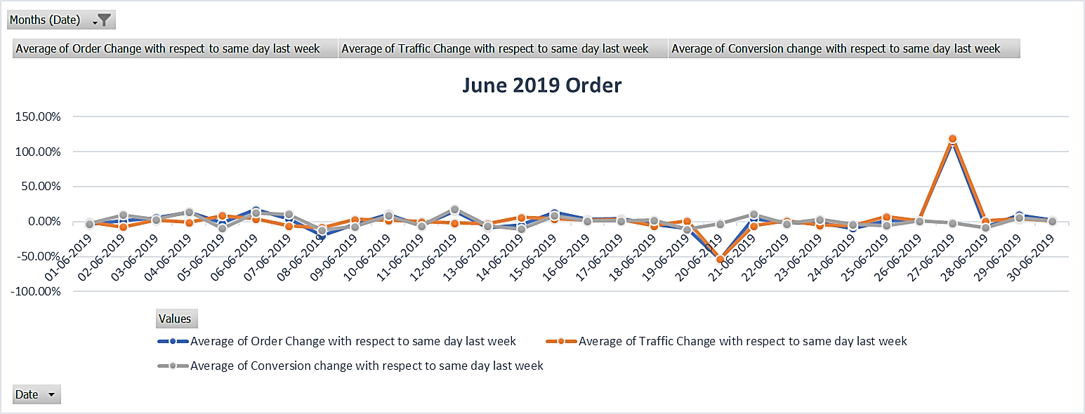

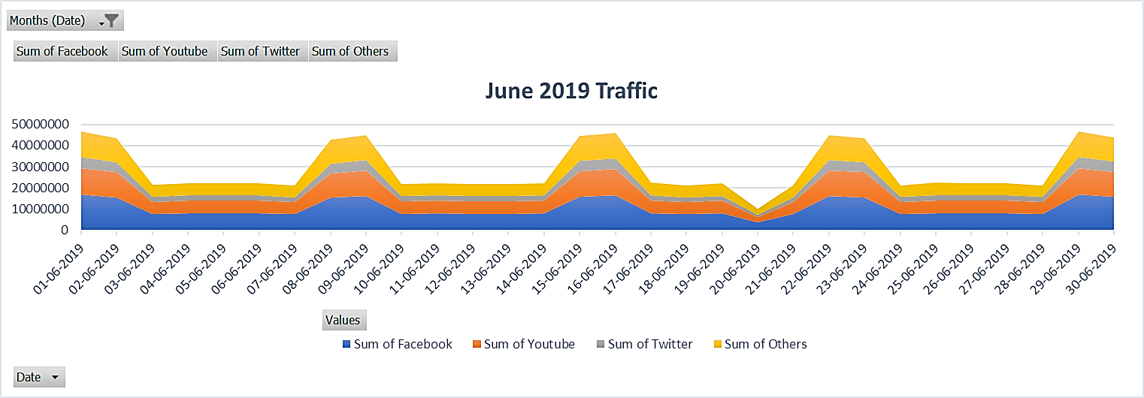

|  |  |  |
| --- | --- | --- |
| Date | Order Fluctuation | Reason |
| 20-06-19 | 54% Drop | A **53% drop in traffic** compared to the same day the previous week (13-06-2019) contributed to the decrease in orders. |
| 27-06-19 | 115% Rise | A remarkable **119% rise in traffic** compared to the same day the previous week (20-06-2019) led to the significant increase in orders. |

* + **July – 2019**

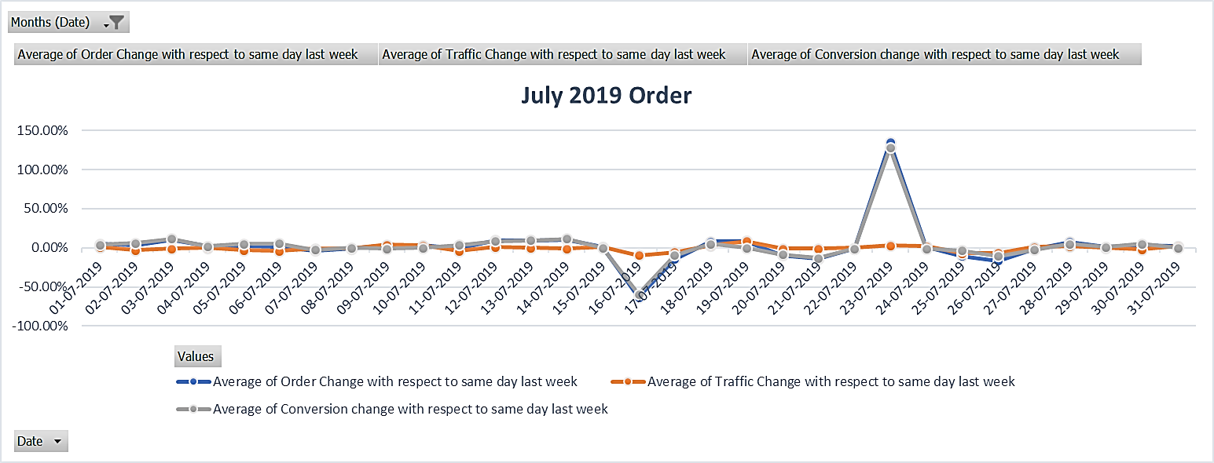

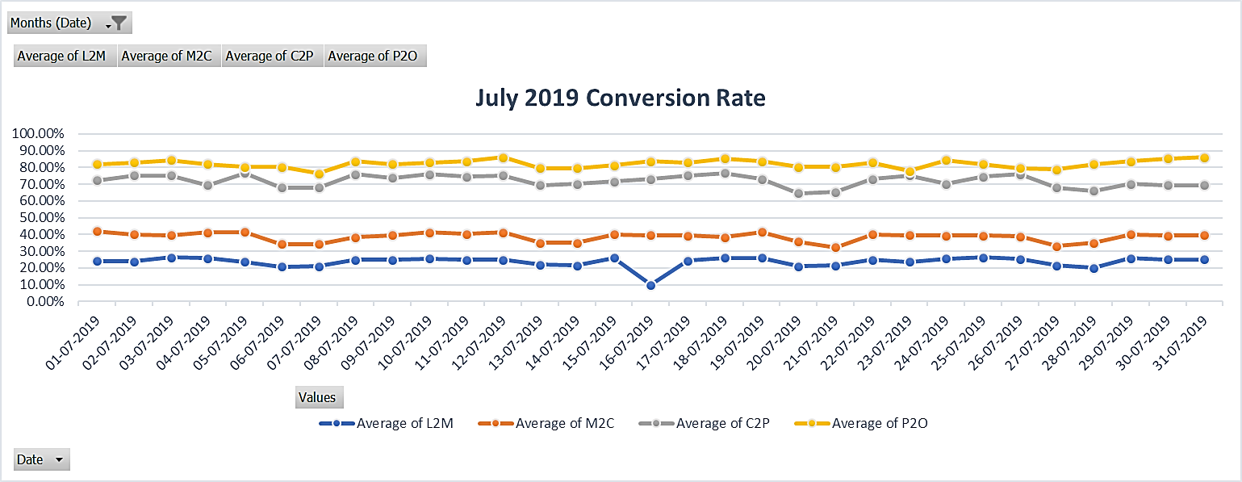

|  |  |  |
| --- | --- | --- |
| Date | Order Fluctuation | Reason |
| 16-07-19 | 63% Drop | A **drop in L2M** (Listing to Menu) conversion rate (from 25% on 09-07-19 to 10% on 16-07-19, compared to the same day the previous week) due to the **rise in Average Cost for Two to 458.** |
| 23-07-19 | 135% Rise | A **rise in L2M** (Listing to Menu) conversion rate (from 10% on 16-07-19 to 24% on 23-07-19, compared to the same day the previous week). |

* + **August – 2019**

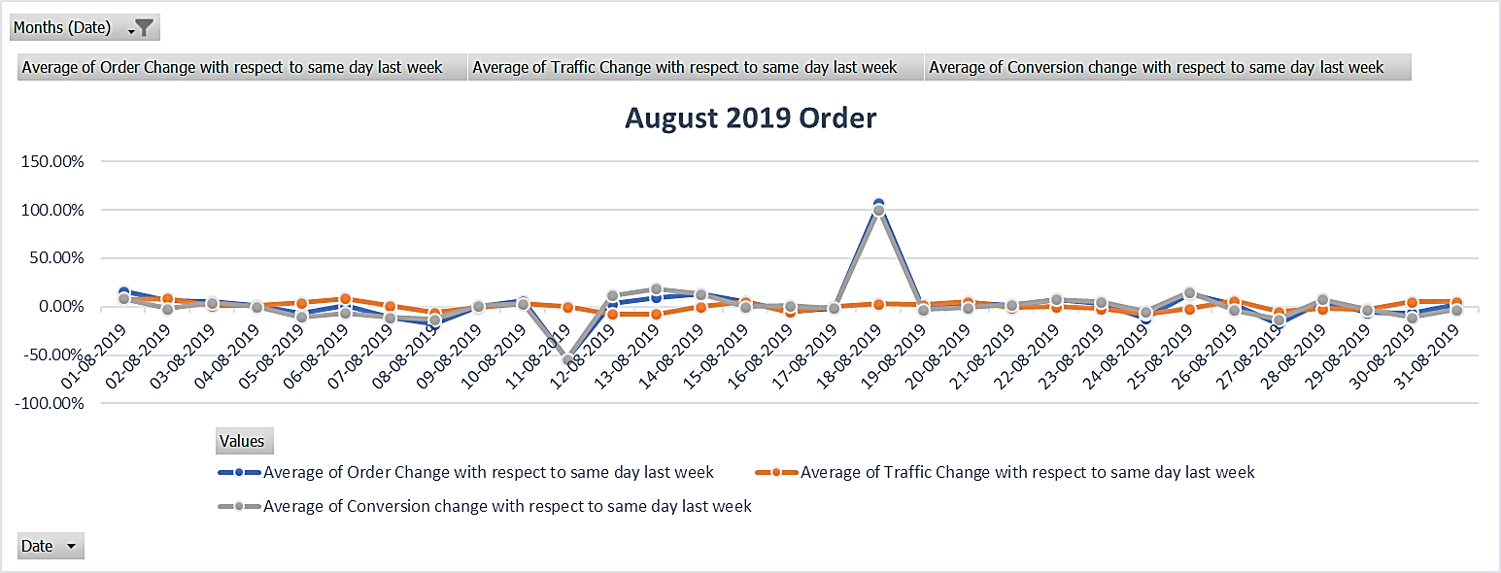

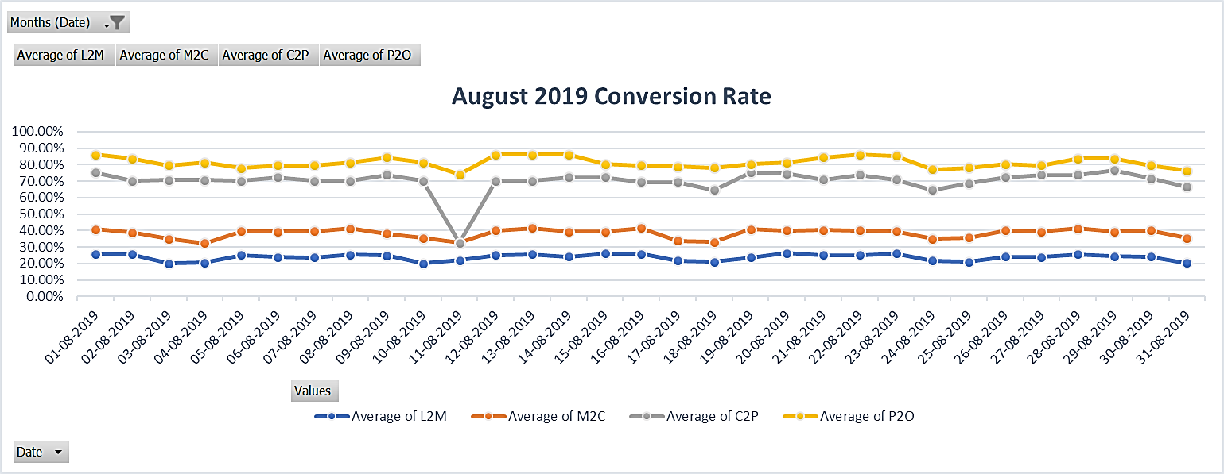

|  |  |  |
| --- | --- | --- |
| Date | Order Fluctuation | Reason |
| 11-08-19 | 54% Drop | A **drop in C2P** (Cart to Payment) conversion rate (from 71% on 04-08-19 to 33% on 11-08-19, compared to the same day the previous week) due to the **rise in Average Packaging Charges to 29.** |
| 18-08-19 | 107% Rise | A **rise in C2P** (Cart to Payment) conversion rate (from 33% on 11-08-19 to 65% on 18-08-19, compared to the same day the previous week). |

* + **September – 2019**

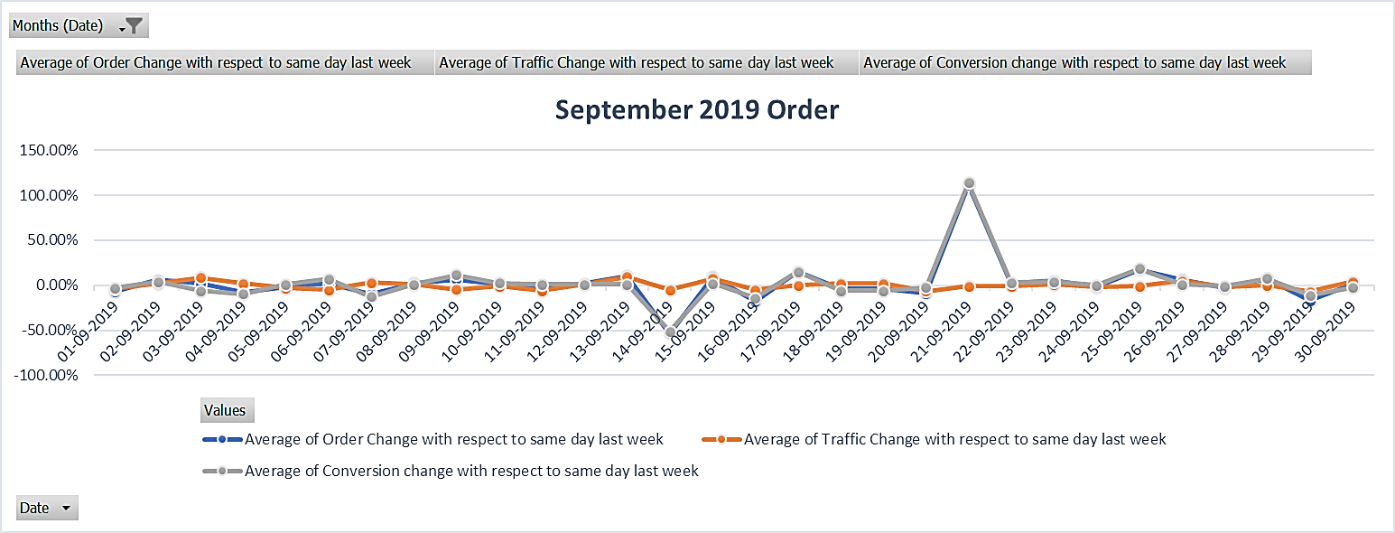

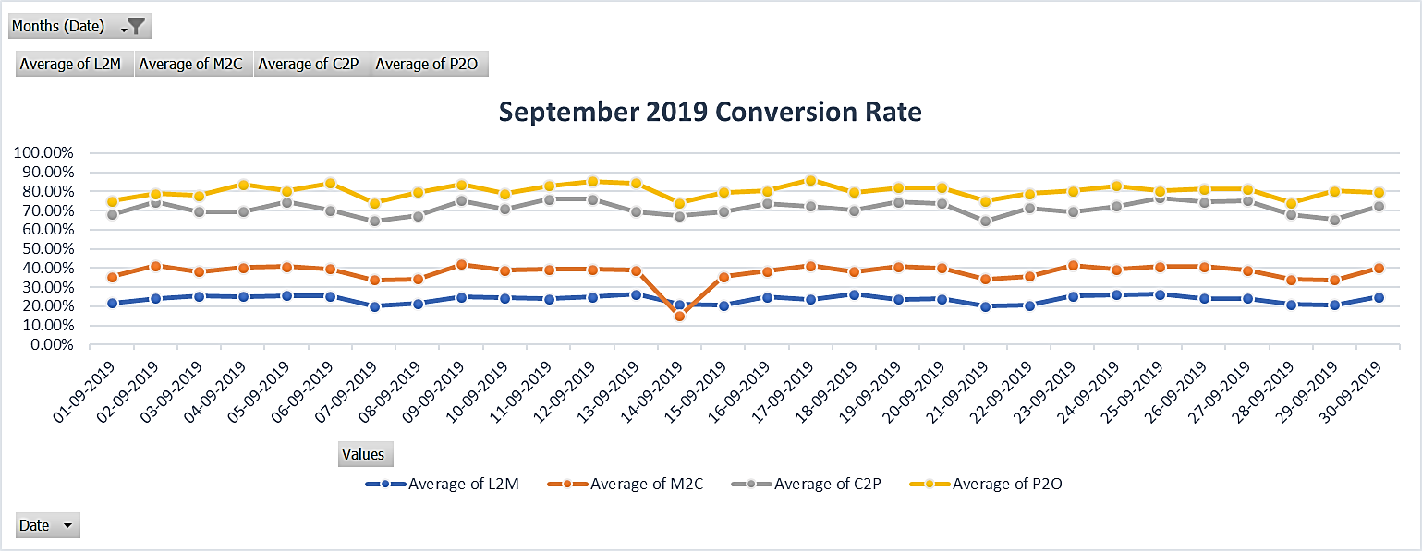

|  |  |  |
| --- | --- | --- |
| Date | Order Fluctuation | Reason |
| 14-09-19 | 54% Drop | A **drop in M2C** (Menu to Cart) conversion rate (from 34% on 07-09-19 to 15% on 14-09-19, compared to the same day the previous week) due to the **rise in Out-of-Stock items per Restaurant to 64.** |
| 21-09-19 | 112% Rise | A **rise in M2C** (Menu to Cart) conversion rate (from 15% on 14-09-19 to 34% on 21-09-19, compared to the same day the previous week). |

* + **November – 2019**

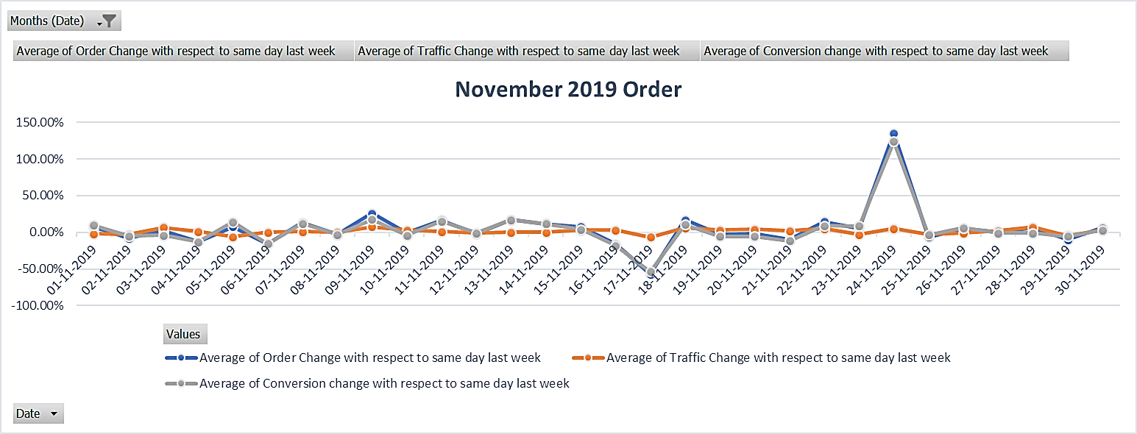

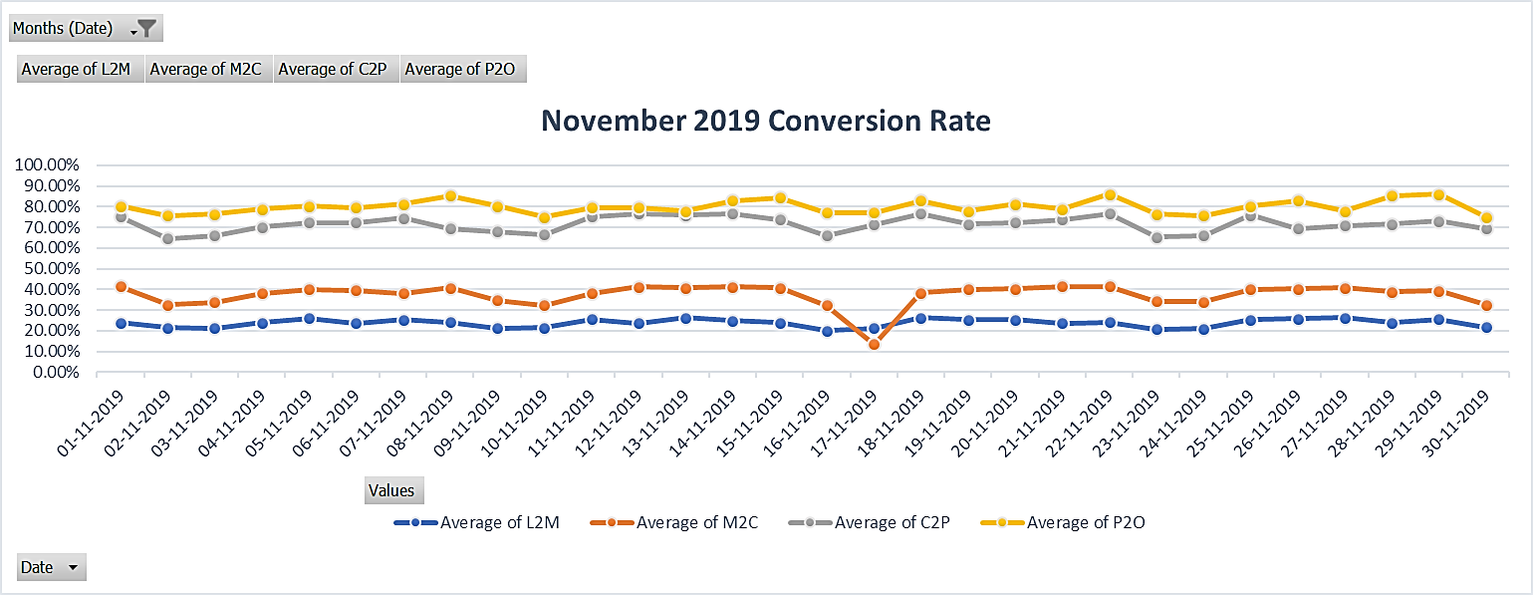

|  |  |  |
| --- | --- | --- |
| Date | Order Fluctuation | Reason |
| 17-11-19 | 57% Drop | A **drop in M2C** (Menu to Cart) conversion rate (from 32% on 10-11-19 to 14% on 17-11-19, compared to the same day the previous week) due to **the rise in Out-of-Stock items per Restaurant to 112.** |
| 24-11-19 | 135% Rise | A **rise in M2C** (Menu to Cart) conversion rate (from 14% on 17-11-19 to 34% on 24-11-19, compared to the same day the previous week). |

Note:

Some charts, including those related to traffic, orders, and conversions, are not included in the analysis as they exhibit normal behaviour without any outliers or extreme fluctuations throughout the month.

1. **Conclusion:**

In analysing Swiggy's performance in 2019, it is evident that the platform experienced both fluctuations and challenges in its order conversion funnel. The L2M (Listing to Menu), M2C (Menu to Cart), C2P (Cart to Payment), and P2O (Payment to Order) conversions played significant roles in shaping the outcomes throughout the year.

* + **Insights Regarding L2M, M2C, C2P, and P2O Conversions**
    1. Several date-based decreases in L2M conversion were observed. These drops were associated with factors such as high costs for two, average packaging charges, and issues related to channel-wise traffic.
    2. Decreases in M2C conversion were identified on specific dates due to various factors, including out-of-stock items, high delivery charges, and average discounts.
    3. A drop in C2P conversion was associated with factors like average delivery charges, overall conversion (order/listing), and issues related to channel-wise traffic.
    4. Decreases in P2O conversion were linked to the success rate of payments. Payment-related issues can negatively impact the P2O conversion.

In conclusion, Swiggy's performance in 2019 was subject to fluctuations influenced by a range of factors, especially in the context of different stages of the order conversion funnel. By addressing these specific conversion steps and acting on the recommended strategies, Swiggy can not only mitigate challenges but also enhance its overall customer experience and order placements. This data-driven approach will be essential for sustaining and growing the platform's success in the competitive food delivery market.

1. **Recommendations**

* **L2M Conversion**:

To improve the L2M conversion, consider enhancing the visibility and attractiveness of restaurant listings. Highlight popular dishes, offer promotions, and ensure that menus are up-to-date.

* **M2C Conversion**:

Address issues affecting the M2C conversion, such as out-of-stock items, slow loading menus, or any other barriers to adding items to the cart.

* **C2P Conversion**:

Ensure a smooth transition from the cart to the payment stage. If high delivery or packaging charges are affecting this, consider offering more transparent pricing or promotions to offset these costs.

* **P2O Conversion**:

If payments are causing issues with P2O conversion, investigate and resolve payment gateway problems, improve success rates, and provide customer support.

* **Channel-wise Traffic**:

Monitor channel-wise traffic closely and invest in marketing strategies that have proven effective in driving traffic increases.

* **Discounts**:

Evaluate the impact of discounts on customer behaviour. Adjust discount strategies to make them more appealing.

* **Average Costs**:

Consider the impact of meal costs on customer decisions and possibly offer more budget-friendly options.

* **Out-of-Stock Items**:

Address issues related to out-of-stock items, which can negatively impact customer experience.

* **User Experience**:

Continuously work on improving the overall user experience, including website and app functionality, payment processes, and menu availability.